**Chapter-1**

**Study of Existing system and system requirements.**

**Hardware & Software Requirement:**

**Hardware Interfaces**

* Minimum Hardware requirement
* Processor: P4 3.0 GHz
* RAM:1 GB or Higher
* Monitor
* Mouse
* Hard disk: 80 GB

**Software Interfaces**

* Minimum Software requirement
* Spring Boot
* Spring MVC
* Java (JSP and Servlet)
* Apache Tomcat Server

All these types of software automatic configure inside operating system after installation it having Java, MYSQL, Apache and operating system base configuration file, it doesn’t need to configure manually.

Introduction

Car Rental Systemproject from the name itself we can understand it is develop to rent cars online. It allows the users those are registered on the application can easily book car for a particular time frame.

I have developed Car Rental System web application where we have all roles including Admin and User. Here, Admin’s responsibility is to add new car according to their brands. Also, Admin can view all the users registered on the website and also can view the booking report. Another role is the User who can view Cars, Book them and also can download receipt.

This application will not only help the Car owners but also the User to book cars online.

Objective

Car Renting Service plays an important role in today’s world. To the customer who wants to travel for some occasion, he/she can book the car online for a particular period of time instead of going to that place for booking. It is also built for the company that wants to rent their car online.

The major objective of this application is to provide a bug-free application to the company owners as well as the user (customer). Along with that build a secured, robust Car Rental system. It maintains the record of users, cars, booking efficiently so that it would be easy to access at any time 24*7.

There are two main roles in this application. One is the Admin and another one is the user(customer).Admin who is the main user of this application has a responsibility of managing overall application like adding cars, deleting it, updating car Information and so on.

Admin can view who has book the cars and at what time from the Booking report section. Another User is the customer for whom the application is built. They can book any car from the available cars.

Methodologies

There are two main roles in this application. One is the Admin and another one is the user (customer). Now, let us discuss the functionality of both.

**1) Admin**

* Admin can ADD/VIEW/UPDATE/DELETE Car Brands.
* Admin can ADD/VIEW/UPDATE/DELETE Vehicle.
* It can VIEW the registered customers.
* Admin can VIEW the Booking Report.

**2) Customer**

* Customers can VIEW the list of cars based on brands.
* Customers can Book a car.
* It can VIEW the Booking report.
* Customers can download the Receipt also.

**Note: The login, profile section and change password are also present in the system.**

**Chapter-2**

**System Analysis**

**2.1 E R DIAGRAM**

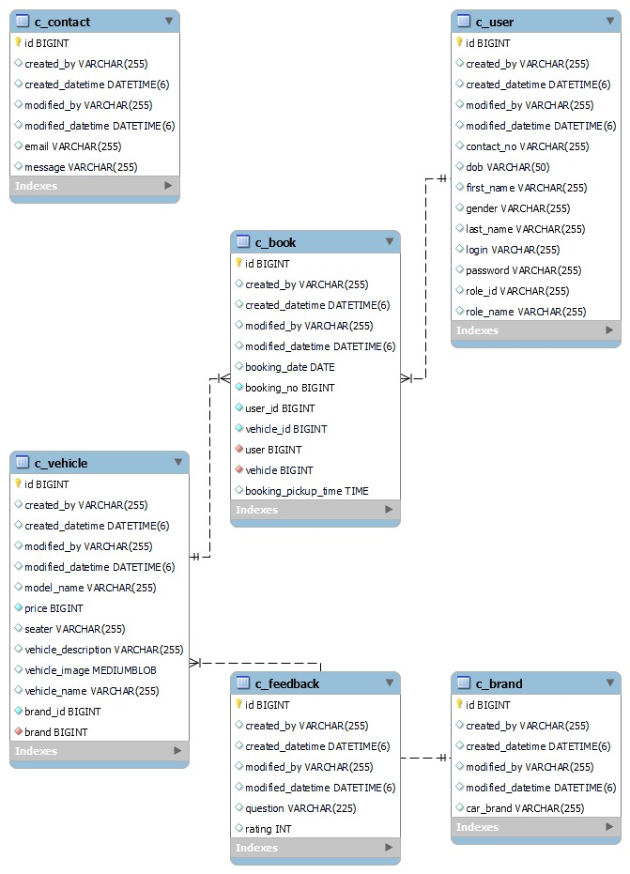

**Data Flow Diagram (DFD)**

**Level 0:**

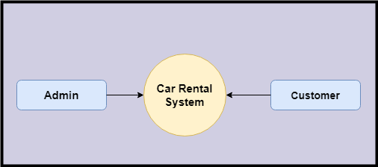

**Level 1**

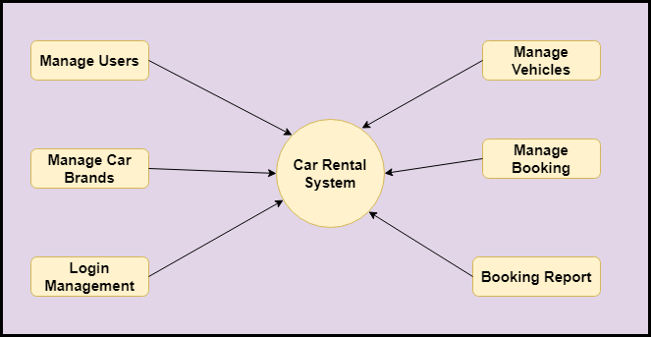

**Level 2-DFD Admin**

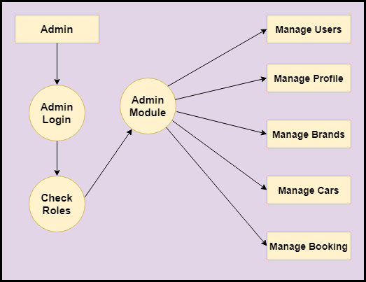

**Level 2 DFD – Customer**

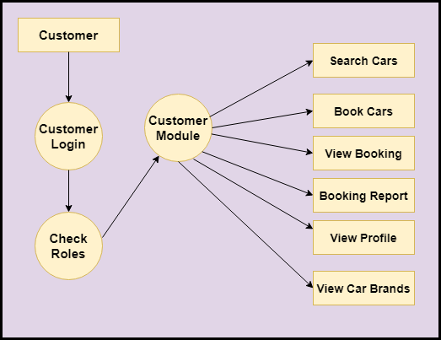

**Feasibility:**

This project will be developed on computer, so first check whether the technology is technically available or not. Now a day’s computer interaction with any job becomes common for any kind of job or work.

And because of increasing usage of Computer, Computer is also available with a variety of hardware. Vendors can fulfill any type of hardware requirement. The whole project is developed by some special tools or by using languages and databases, which are also available in a variety.

Preliminary investigation of a system examines the feasibility of a system that is useful to an organization. It is the first phase of system development.

The main objective of this phase is to identify the current deficiencies in the user’s environment and to determine which existing problem are going to be solve in proposed system and also which new function needs to be added in proposed system.

An important outcome of such preliminary investigation is to determine whether the system that will meet all needed requirements.

Thus, three tests are carried out on the system namely operation, technical and economical.

Any project is beneficial if and only satisfies the organization requirement. For any new system setup, it only meets to be communicated and work the other supporting system.

The new system meets all existing operations since it provides right information at a right time to the right user. A Leigh man can easily operate with the system.

Technical Feasibility examines whether the technology needed is available and if it is available then it feasible to carry out all project activities.

The technical needs of a system include:

* The facility to produce outputs in a given time.
* Ability to process large number of transaction at a particular speed.
* Giving response to users under certain conditions.

The technology needed for our system is mainly:

* Latest version of browsers.
* Any operating system.

These technologies are available which helps to carry out the system efficiently.

Economical feasibility of a system examines whether the finance is available for implementing the new system and whether the money spent is recoverable the satisfaction.

The cost involves is in designing and developing a good investment for the organization.

Thus, hardware requirements used for proposed system are very standard. Moreover, by making use of proposed system to carry out the work speedily will increase and also saves the valuable time of an organization.

In the proposed system the finance is highly required for the installation of the software’s which can also be recovered by implementing a better system.



**Chapter-3**

**Design**

**System Flow Chart:**

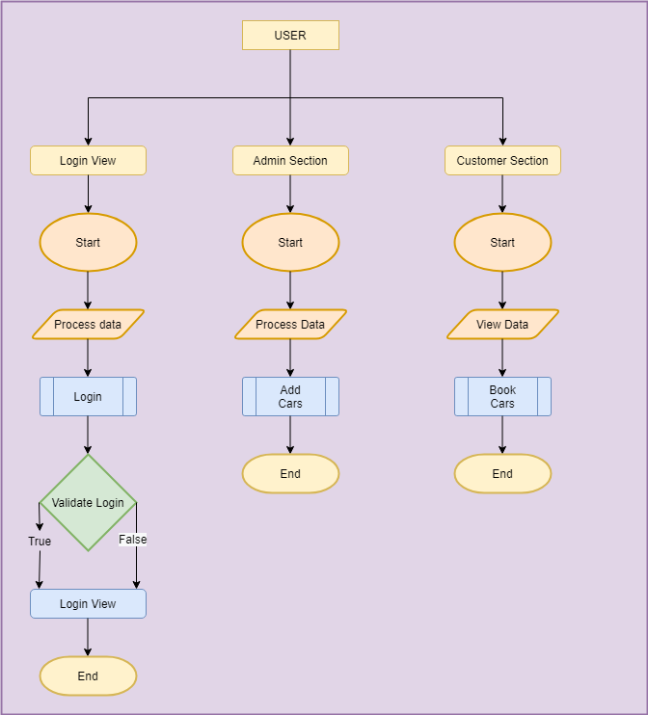

**Data dictionary**

**Data validation:**

Procedures are designed to detect errors in data at a lower level of detail. Data validations have been integrated in the system in almost every area where there is a possibility for the user to commit errors. The system will not recognize invalid data.

Whenever an invalid data is keyed in, the system immediately prompts the user and the user has to again key in the data and the system will accept the data only if the data is correct. Validations have been integrated where necessary.

The system is designed to be a user friendly one. In other words the system has been designed to communicate effectively with the user. The system has been designed with pop up menus.

**Different Type Of validation:**

* Data type validation;
* Range and constraint validation;
* Code and Cross-reference validation; and Structured validation

**Coding**

**Implementation and Testing:**

**Black-Box Testing**:

Black Box Testing, also known as Behavioural Testing, is a software testing method in which the internal structure/ design/ implementation of the item being tested is not known to the tester. These tests can be functional or non-functional, though usually functional.

This can be following way:

* Input interfacing
* Processing
* Output interfacing



This method is named so because the software program, in the eyes of the tester, is like a black box; inside which one cannot see. This method attempts to find errors in the following categories:

* Incorrect or missing functions
* Interface errors
* Errors in data structures or external database access
* Behaviour or performance errors
* Initialization and termination errors.

**White-Box Testing:**

White Box Testing ,also known as Clear Box Testing, Open Box Testing, Glass Box Testing, Transparent Box Testing, Code-Based Testing or Structural Testing is a software testing method in which the internal structure/ design/ implementation of the item being tested is known to the tester.

The tester chooses inputs to exercise paths through the code and determines the appropriate outputs. Programming know-how and the implementation knowledge is essential.

White box testing is testing beyond the user interface and into the nitty-gritty of a system.

This method is named so because the software program, in the eyes of the tester, is like a white/ transparent box; inside which one clearly sees.

**Limitations and Future Application of the Project**

**Futures Enhancement:**

* In future we can expand this project on cloud.
* In future, we can send messages/notifications to Customer on phone about different deals.
* In future, we can send message about booking.

**Limitation :**

In this, we don’t block the Customer registered.

**Screen Snapshot**

**Conclusion**

The Car Rental System provides a single gateway to the Customer and Admin of the Car Rental Company where they can manage their cars and booking related activity efficiently. Everything will be handled in one place.

It will help the customer to book a car of their choice using our application. This project can be used by big or small scale companies who are looking to rent their cars online.

This application is designed in such a way that any future modification can be done most easily.